**Database Lab Task**

Submitted by: Sharifullah

Submitted to: Basit Ali

1. Q1. Select record of all employees who have joined the company in the Month of Feburary.(any date,any year)

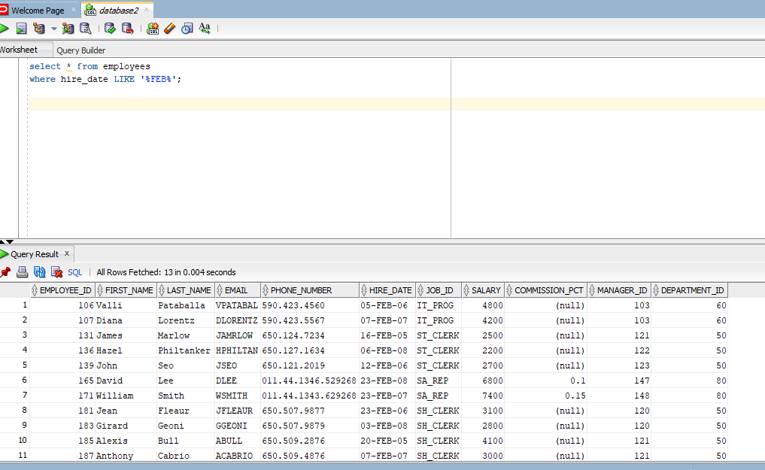

1. Select all records of employees where the first letter of the First_name is NOT an &quot;A&quot; or a &quot;S&quot; or an &quot;F&quot; and department id is not 80 or 70.

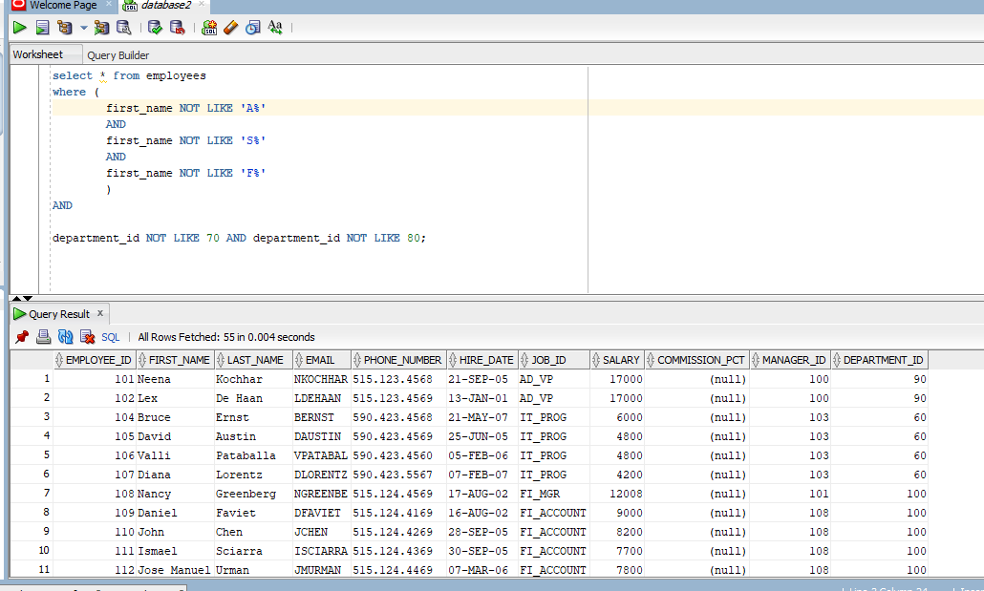

1. Select (Ask user for column name) of employees where employee is (Ask user for id).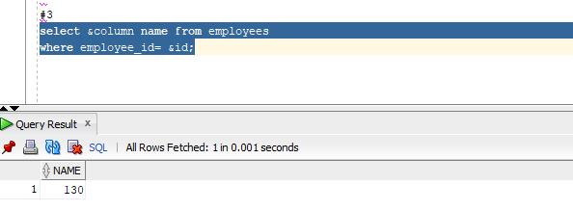
2. Define a variable Employeeid = (of your choice) and define departmentid (ask user to assign the

value to department id) now display all the record of employees having defined variable values.

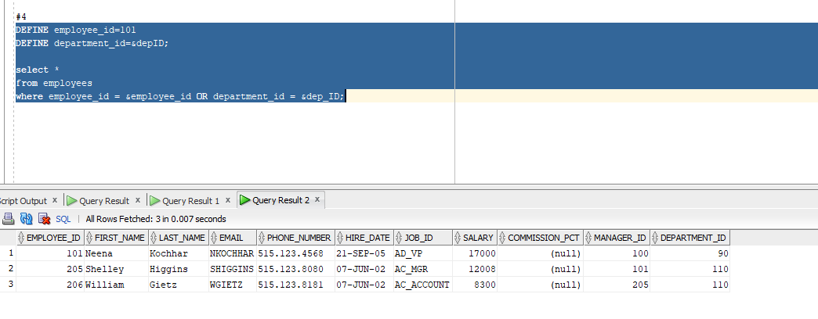

1. We use the **Set Verify On** command to confirm the changes in the SQL statement or to display the text of a command before and after it replaces substitution variables with values.
2. **Single ampersand(&)** is used to prompt the user for taking the value, **double ampersand(&&)** is used to avoid the re-usability of a variable each time and prevent prompting the user again and again. And the **define** is used for creating a variable and assigning a value to it.

* Suppose, I want to prompt the user to search by ID to find a person.

So, I will write emp_id = &ID

* Incase, I want to know the daily bonus of a person which can vary day to day, so here I need the salary only once: I will write Daily_Bonus=&bonus
* If a database administarator is working with heavy data and he’s to much busy, so he may be using a value multiple times, for this kind o f scenario he would better define a variable with that value.

1. **Project, selection and joining:**

* Projection: This operation only selects certain columns(fields) from table.
* Selection: A select operation selects a subset of rows (records) in a table (relation) that satisfy a selection condition.
* Joining: A join operation combines data from two or more tables based on one or more common column values.